

AD SWAT

CA TDM

4.7

**CA Test Data Management 4.7**

**Prepared by : Manjunath Narayan**

**Reviewed by: Keith Puzey**

**Date : November 2018**

**Version : V1.0**

**Table of Contents**

Chapter 2: Prerequisite 3

**2.1** **Pre-requisite / Optional: Backing up current TDM Configurations** 3

**2.2** **Prepare for Upgrade** 3

**2.3** **Upgrade Path for 4.7** 4

Chapter 3: Installation 5

**3.1 Download** 5

**3.2 Installation steps to TDM 4.x** 7

**3.3 Renaming rep.xml file and syncing the repository database** 35

**3.4 Maintenance mode in Datamaker** 40

**3.5 Upgrade steps to TDM Portal 4.x** 43

Chapter 1: Introduction

The purpose of this document is to assist the End user working on CA Test Data Management to upgrade their CA Test Data Management from 3.x version to the latest version. The document will provide step by step approach to upgrade the CA TDM components.

# Chapter 2: Prerequisite

## **Pre-requisite / Optional: Backing up current TDM Configurations**

Review the following link before beginning the upgrade:

<https://docops.ca.com/ca-test-data-manager/4-7/en/installing/upgrade-product-components>

## **Prepare for Upgrade**

To prepare for the upgrade, ensure that all necessary data is backed up and enter your license request, if necessary. If you have already migrated to the new licensing scheme introduced in CA Test Data Manager 3.1.2, you do not require a new license. You can simply reload the license after upgrade until it expires.

Starting with 3.2.2, the upgrade process automatically backs up all product configurations before the upgrade and restores those configurations during upgrade. Therefore, Step 2 is not required for upgrades to 3.5 and later unless you want to create your own backups for extra security.

1. Back up your repository database.  
   This process varies depending on your database. Check with your DBA.
2. (Optional) Back up all enabled CA Test Data Manager configurations as follows, using the TDoD Config Editor as an example:
   1. Navigate to TDM_HOME\Grid-Tools\TDoD\TDoD_Config Editor and run TDoDConfigEditor.exe.
   2. On the Configure Server tab, click Backup.  
      The config editor creates a backup of the configuration file, and a confirmation message appears.
   3. Back up other enabled config editors using the same process.

If enabled, other config editors that support backup are:

* 1. Remote Publish Engine
  2. Rally Batch Service
  3. HP ALM Service
  4. Group Job Process Executor
  5. HP ALM Batch Configuration Service

1. (Optional) Request a license for your upgrade using a Customer Care Case Request: <https://support.ca.com/irj/portal/anonymous/customercare>.  
   This request is only necessary if you are upgrading from an older version or if your license is expiring. Licenses from 3.1.2 and later are reusable with your upgraded software until they expire.  
   Provide your Enterprise Site ID, Product Name (CA Test Data Manager), and release number.  
   When the request is processed, you receive an activation key. If needed, we recommend that you request the license before performing the upgrade to account for the license turnaround time.

## **Upgrade Path for 4.7**

|  |  |
| --- | --- |
| Versions | Suggested Path |
| 3.2 | 3.2->3.5 -> 3.8 -> 4.0->4.2 -> 4.4->4.6->4.7 |
| 3.5 | 3.5->3.8 -> 4.0 -> 4.2->4.4 -> 4.6-4.7 |
| 3.8 | 3.8->4.0 -> 4.2-> 4.4->4.6-> 4.7 |
| 4.0 | 4.0 -> 4.2->4.4->4.6->4.7 |
| 4.1 | 4.1 -> 4.3->4.6->4.7 |
| 4.2 | 4.2 -> 4.4->4.6->4.7 |
| 4.3 | 4.3 -> 4.5 -> 4.7 |
| 4.4 | 4.4 -> 4.6-> 4.7 |
| 4.5 | 4.5->4.7 |
| 4.6 | 4.6->4.7 |

# Chapter 3: Installation

## **3.1 Download**

|  |  |
| --- | --- |
|  | CA Test Data Manager v3.x/4.x can be downloaded from the CA Support site at http://support.ca.com  Download Management  **Note: TDM Portal is available in CA Test Data Manager Full Package** |
|  | Search for **CA Test Data Manager for Data Generation** – **MULTI-PLATFORM or whichever TDM SKU you have listed as per your customer contract**  Select a Release 4.7  **CA Test Data Manager Full Package 4.X** Component should be downloaded. |
| OR |
|  | You can either *Download* from here directly or select *Add to Cart* for the various downloads (as required) and then select *View Download Cart*. |
|  | Choose one of the methods for download and start the download to your Download location |

## 

## **3.2 Installation steps to TDM 4.x**

Go to the location where you chose the zip file to be downloaded to and un-compress the file. Once completed you should see product files as listed below: 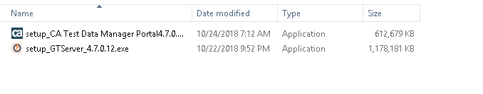

You should now see a setup executable with the Datamaker logo next to it.

Launch the executable by right clicking and select “**Run as administrator**”.

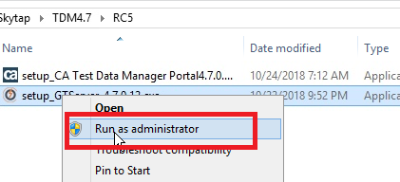

Follow along with the following screen shots.

**Note: During installation/upgrade, It is advised to leave everything as the default selections, unless you have specific components you want or don’t want to install, in which select/deselect as necessary. Also, the target install location should automatically be directed to the current installation, but it is recommended to check/verify that it is correct.**

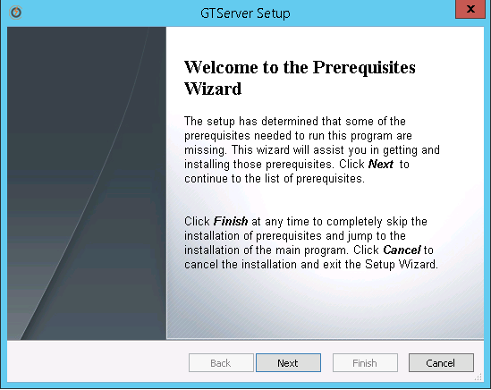

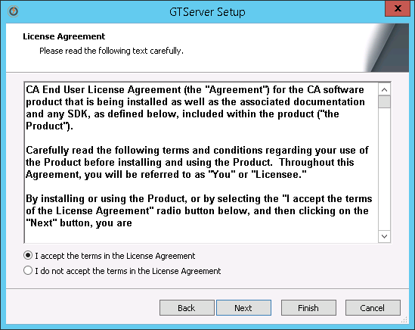

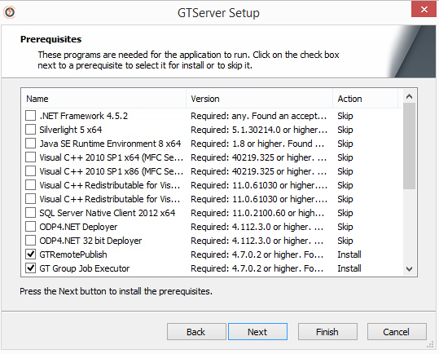

**NOTE:** Any prerequisites that are needed will be installed prior to the installation of the selected components

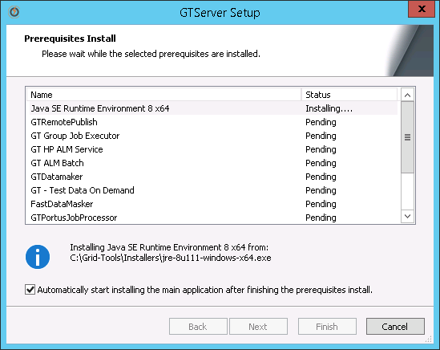

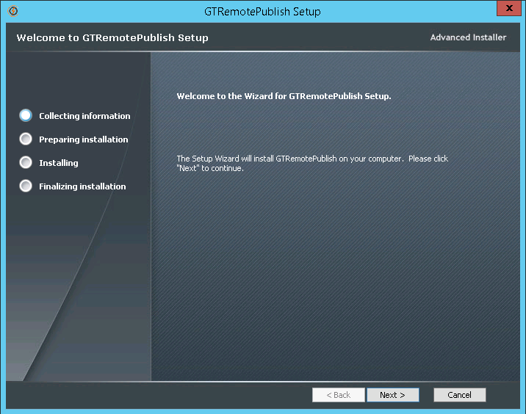

**NOTE:** Verify install destination is correct.

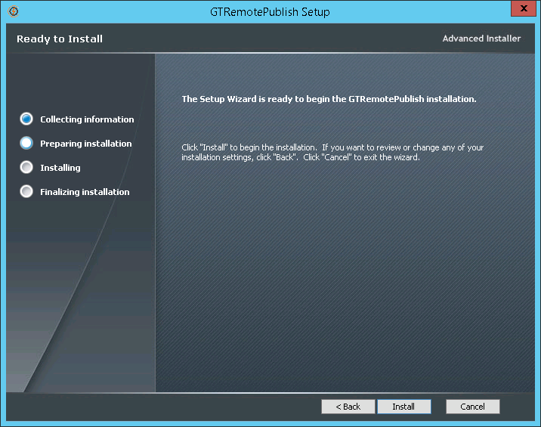

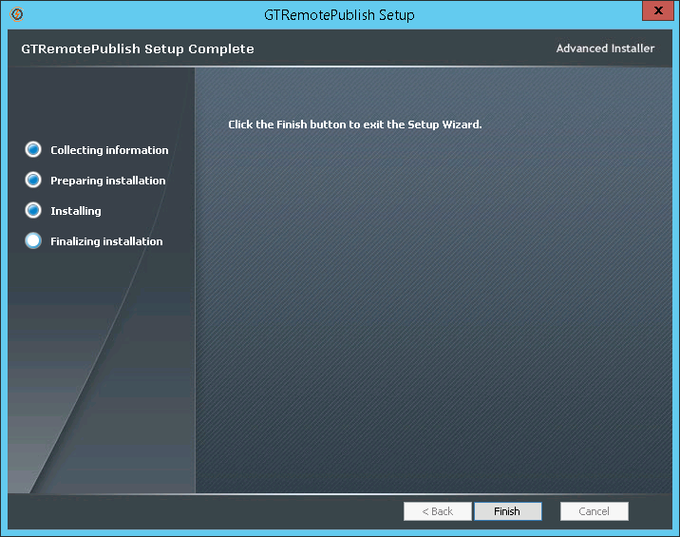

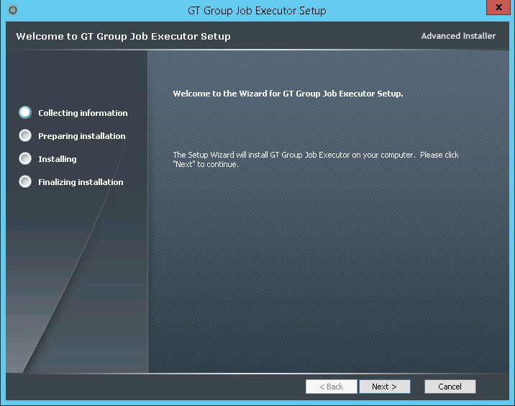

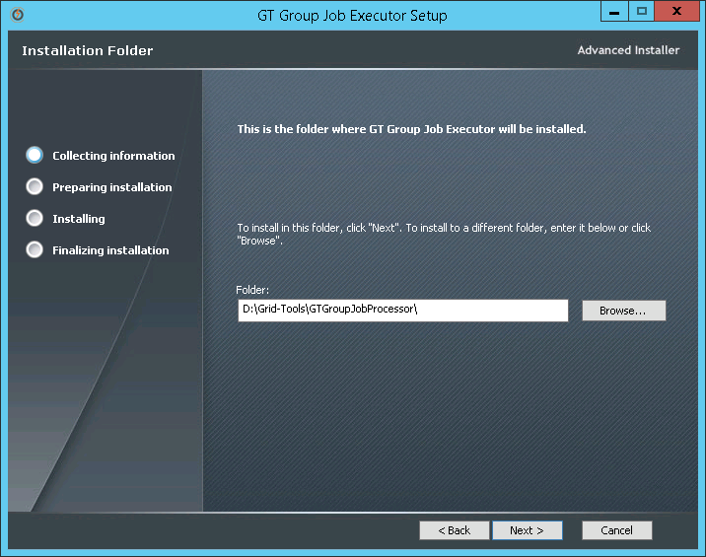

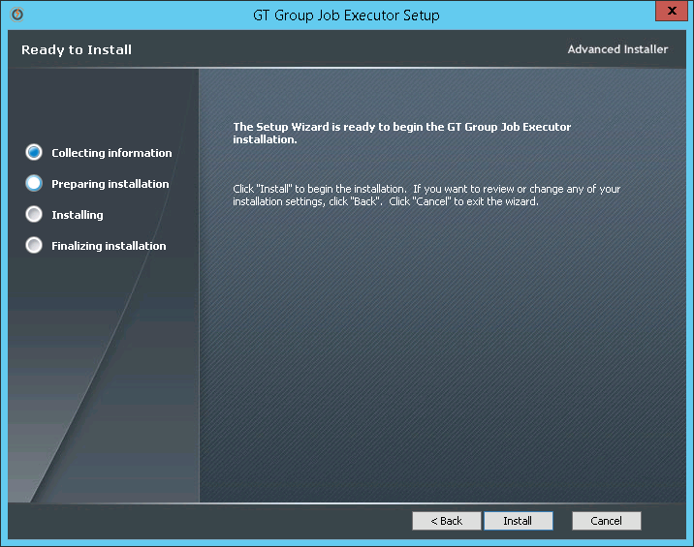

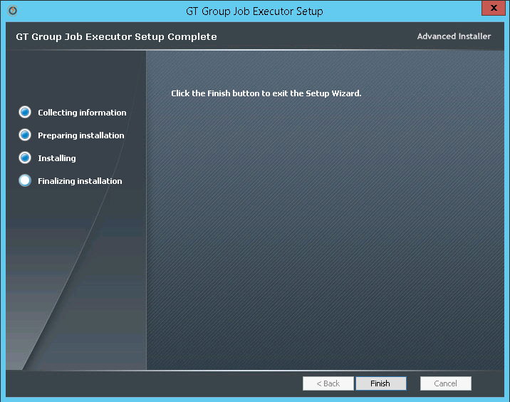

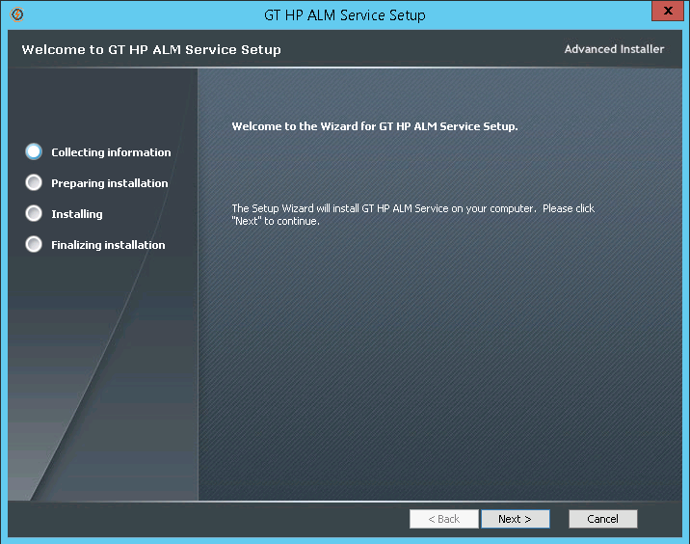

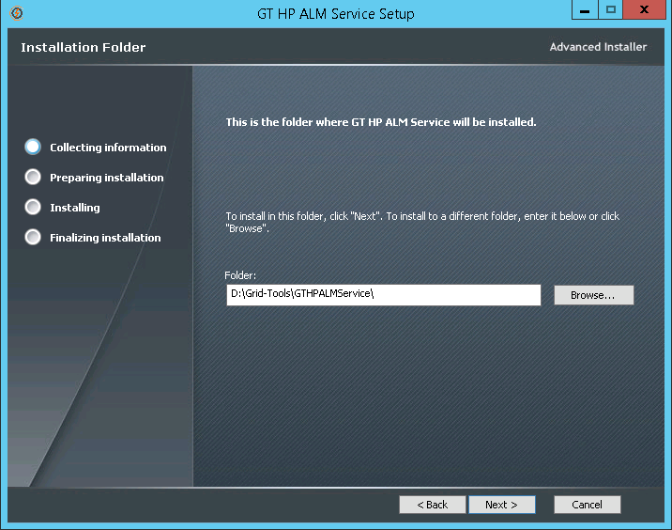

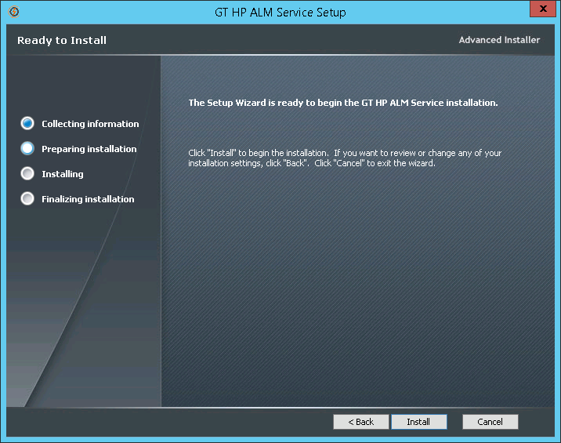

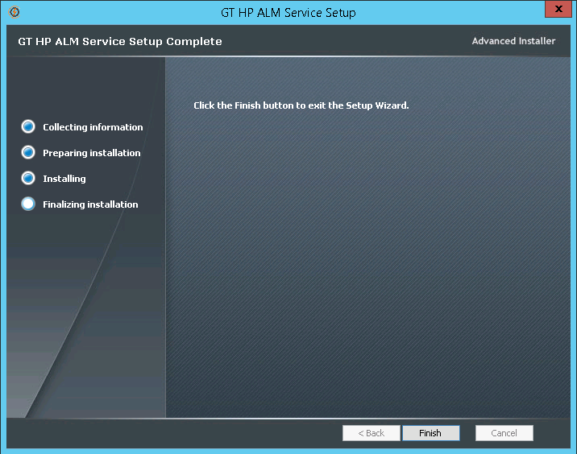

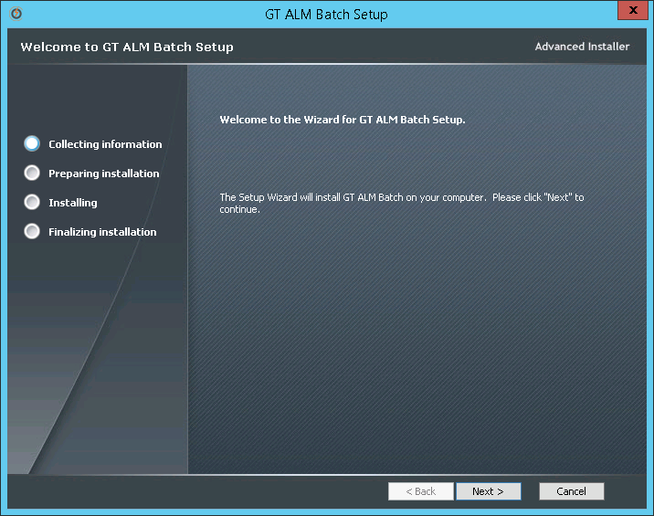

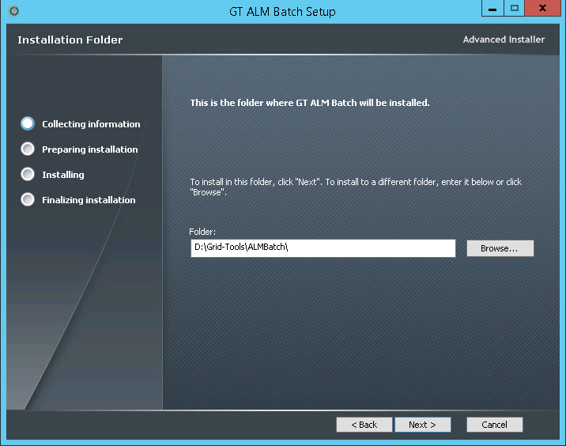

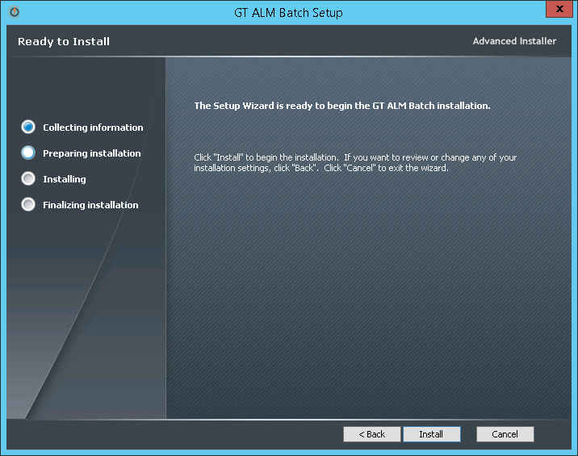

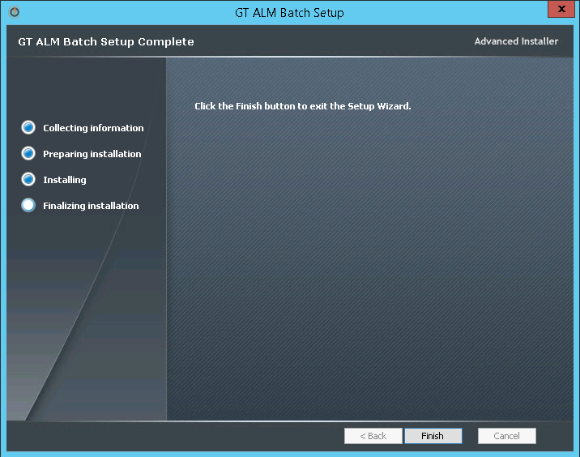

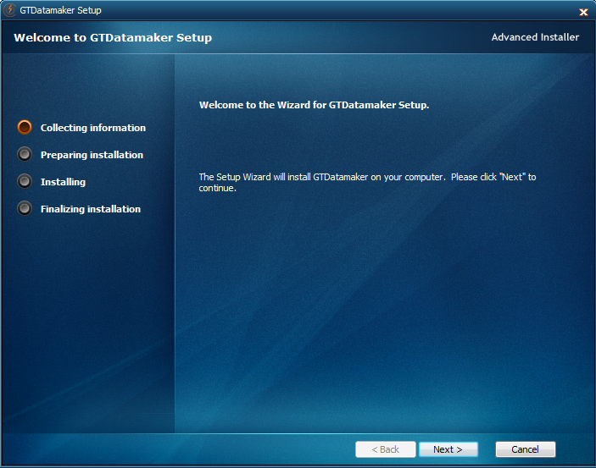

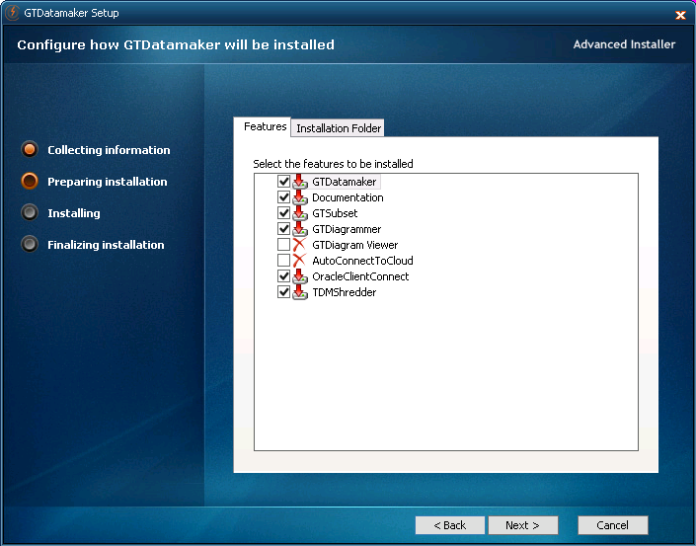

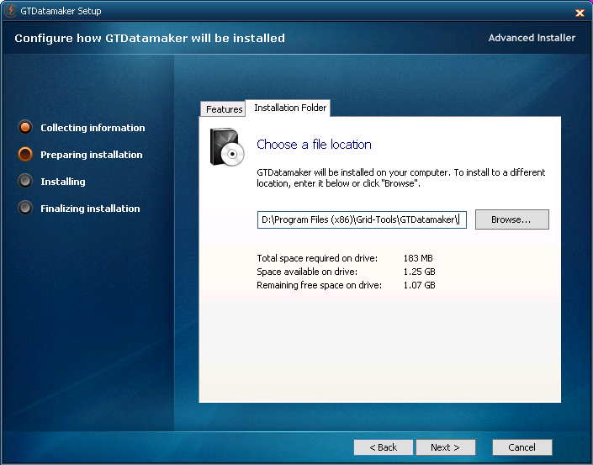

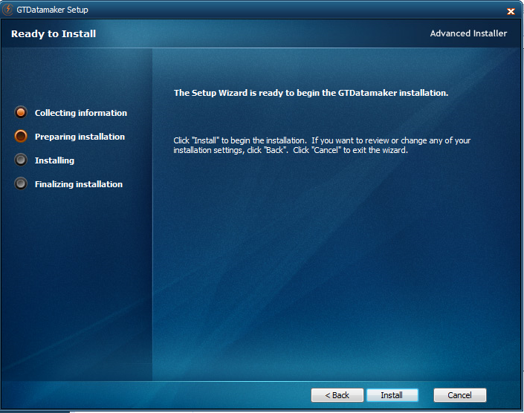

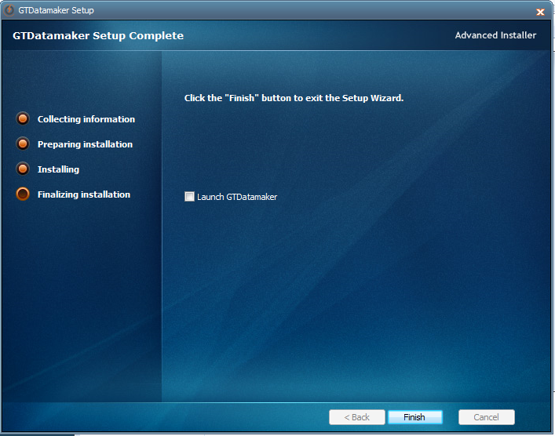

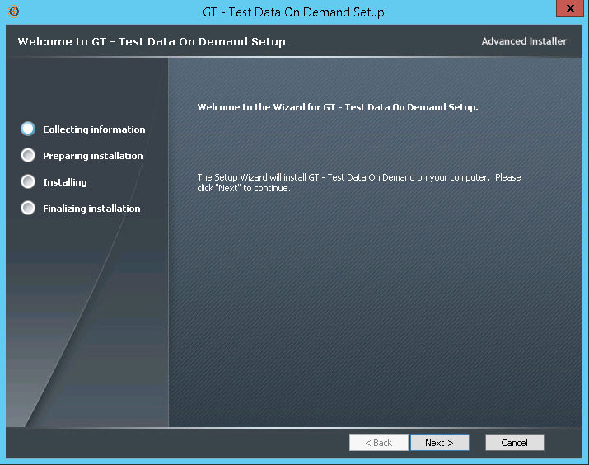

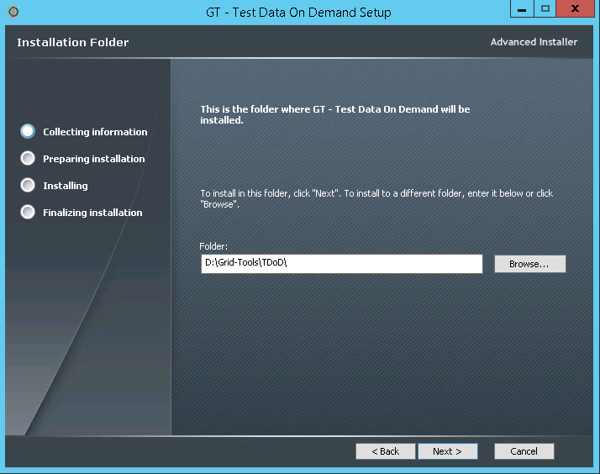

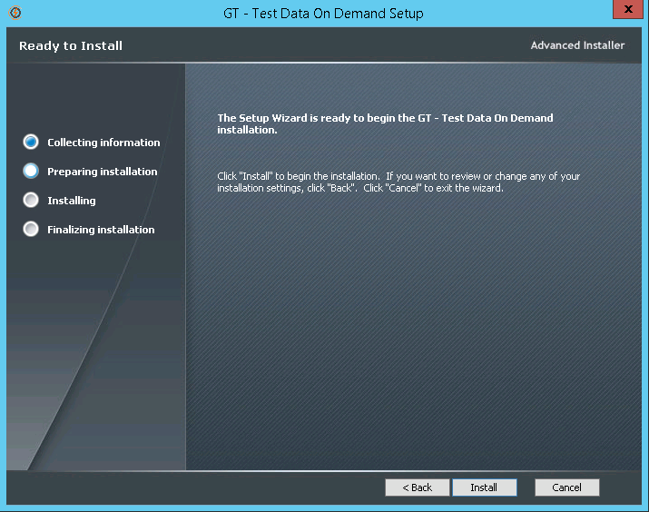

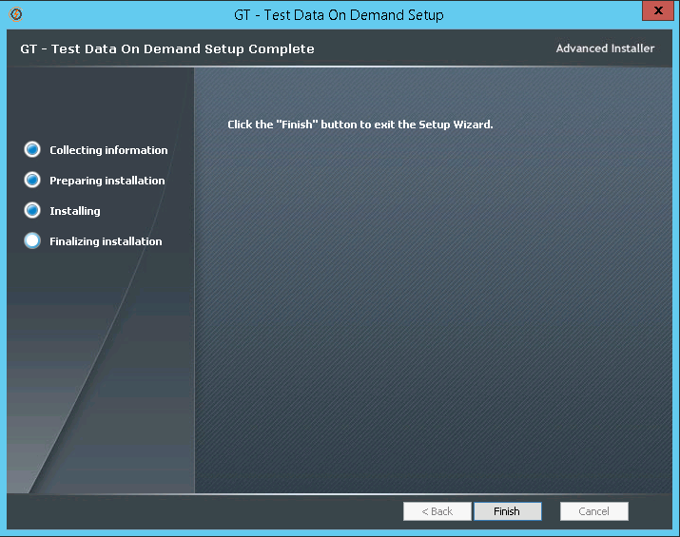

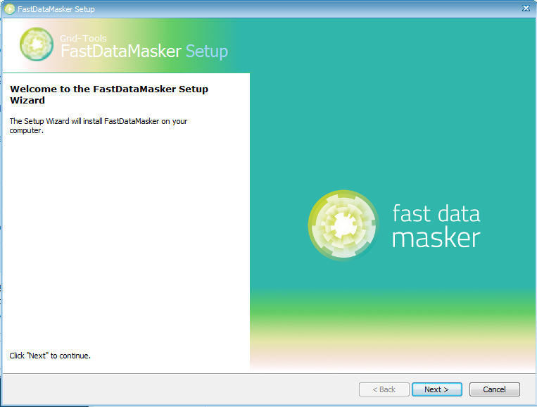

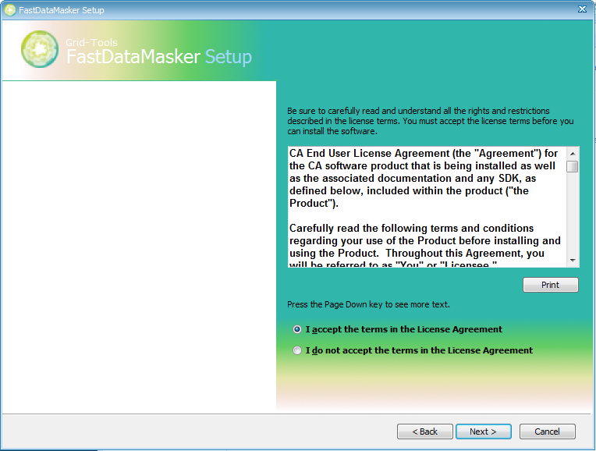

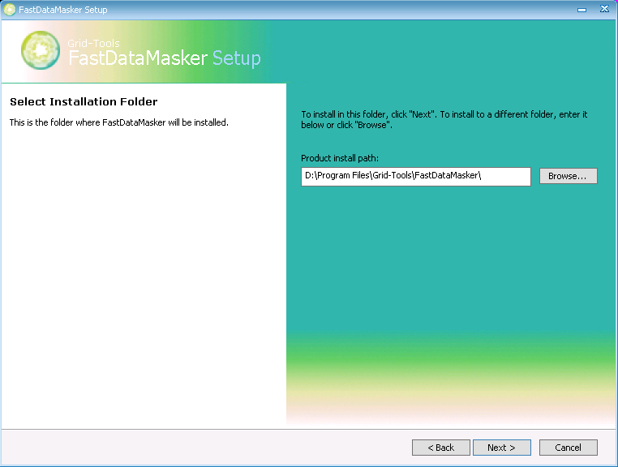

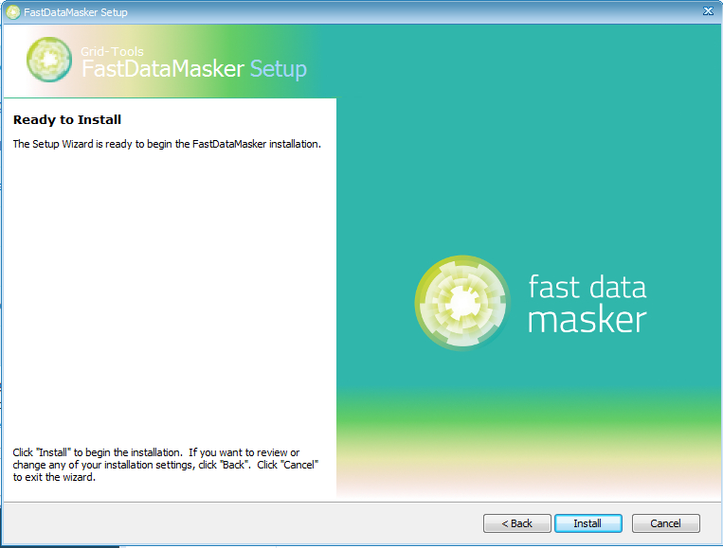

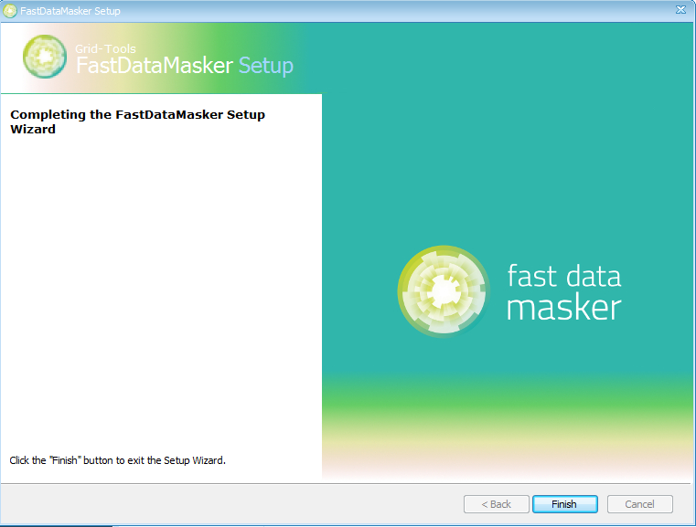

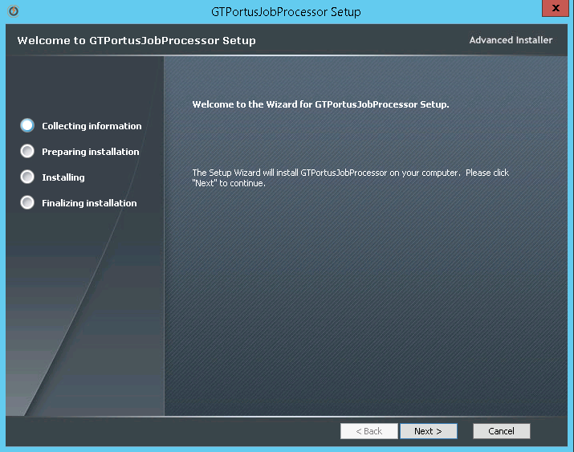

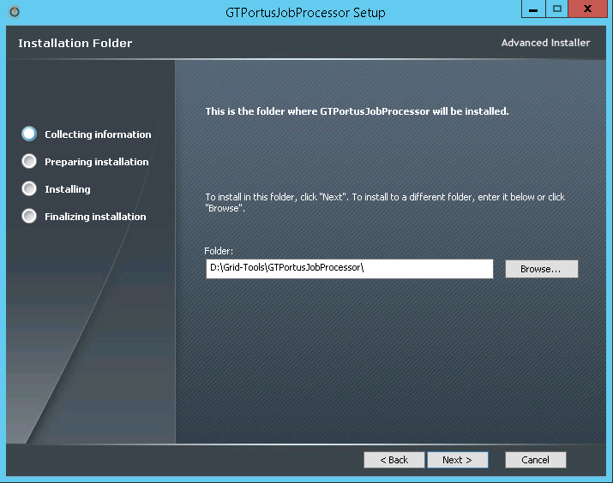

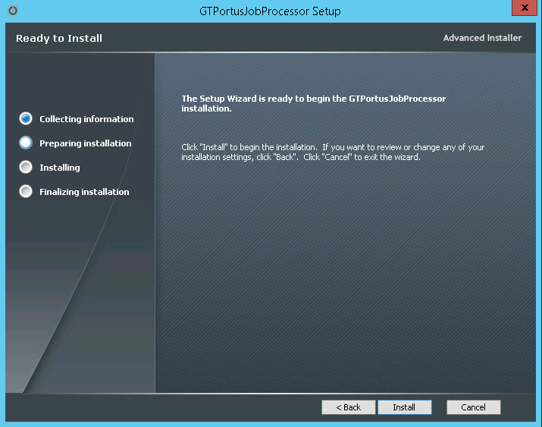

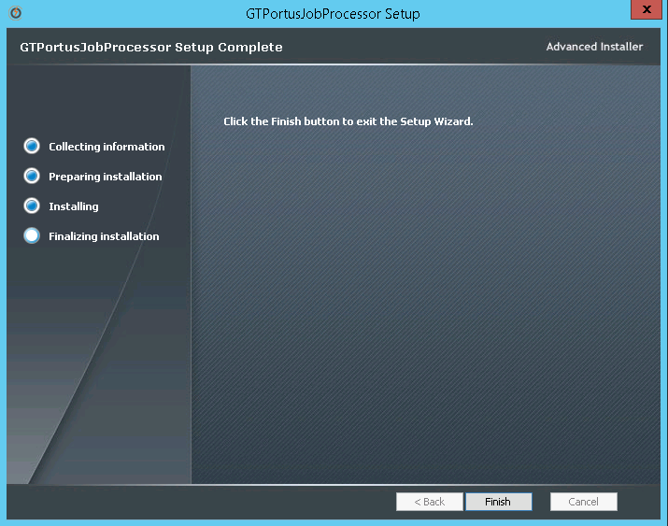

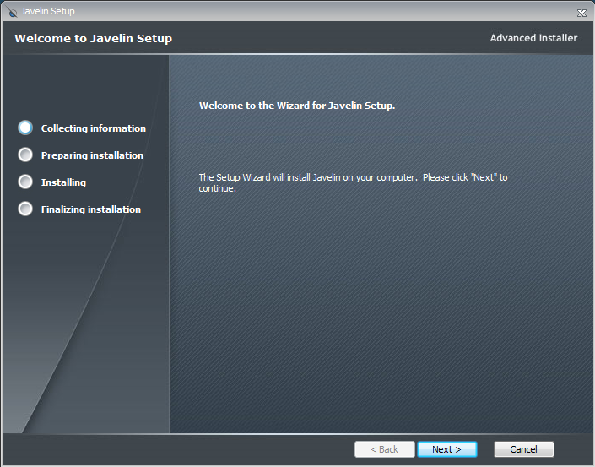

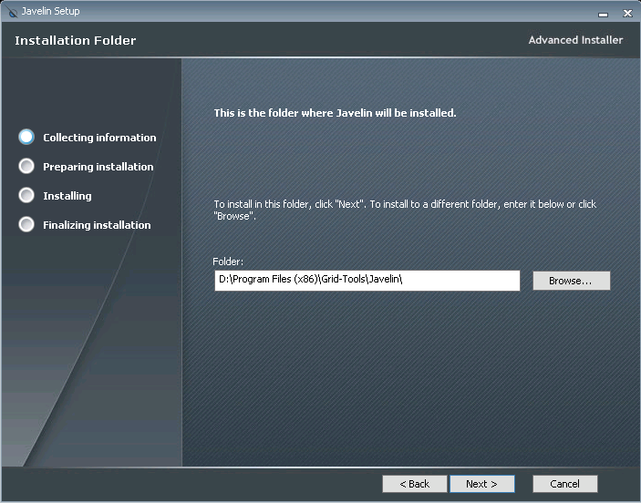

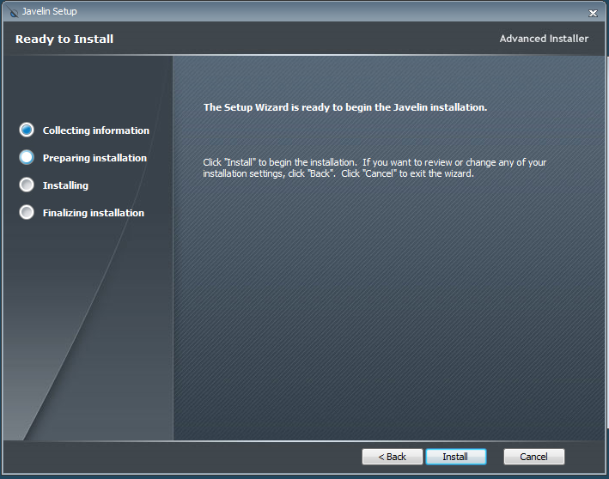

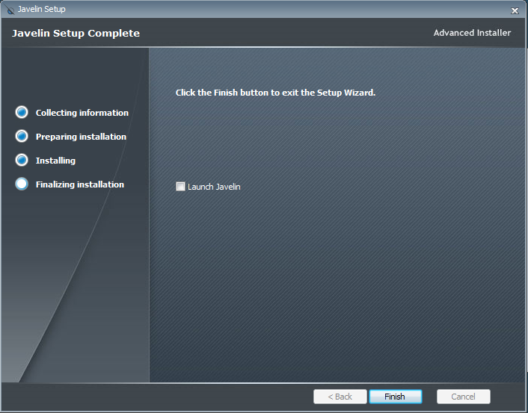

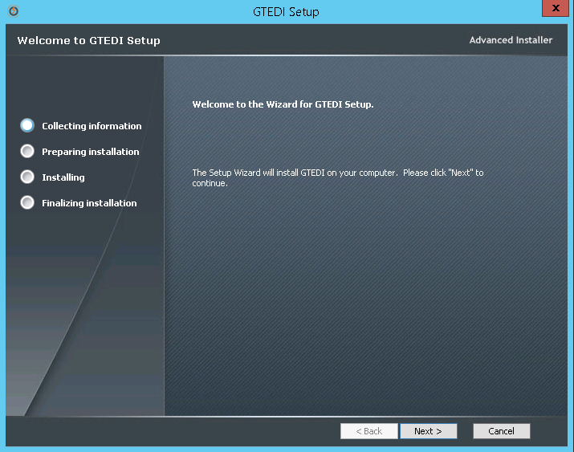

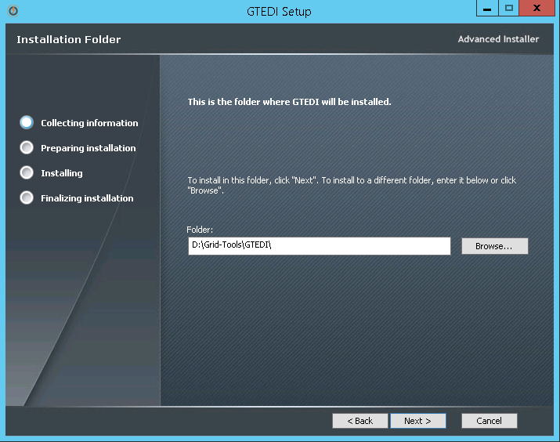

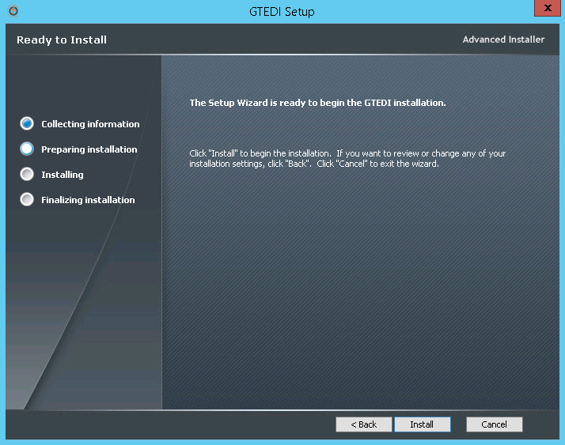

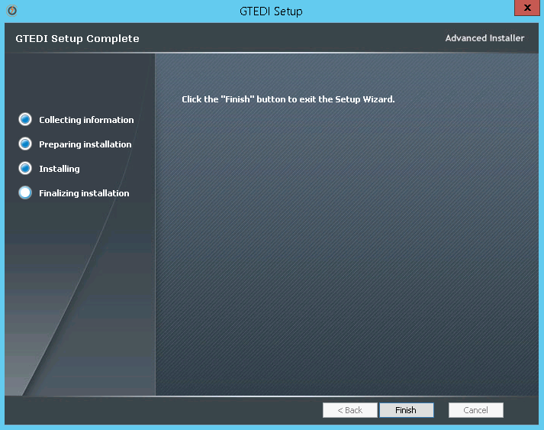

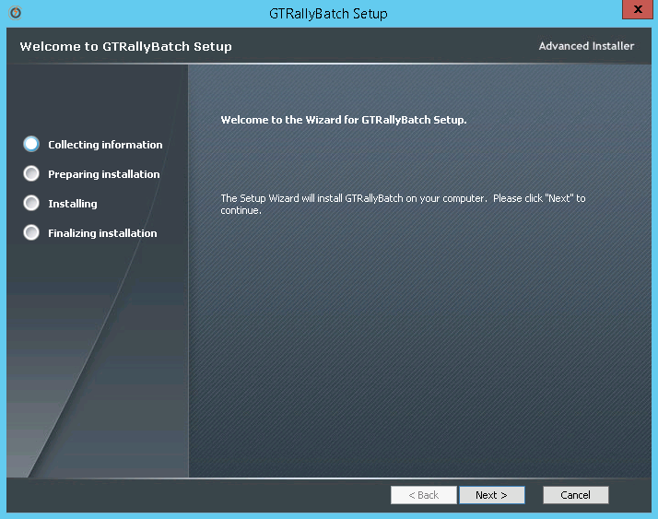

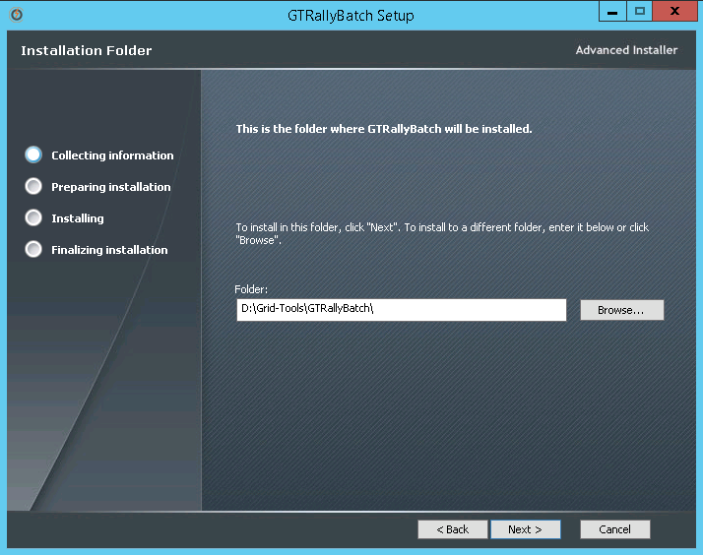

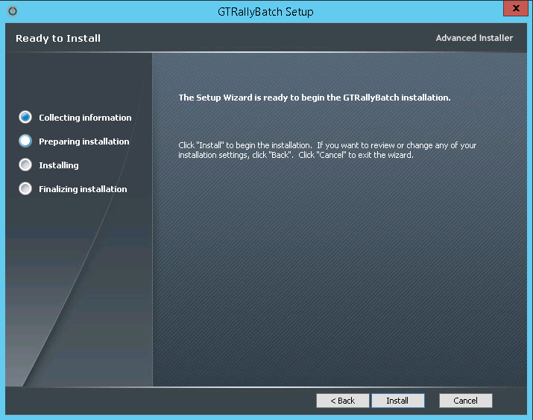

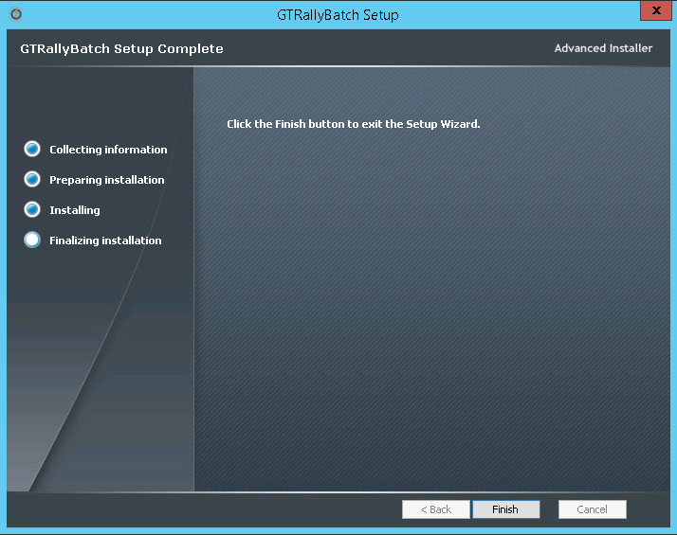

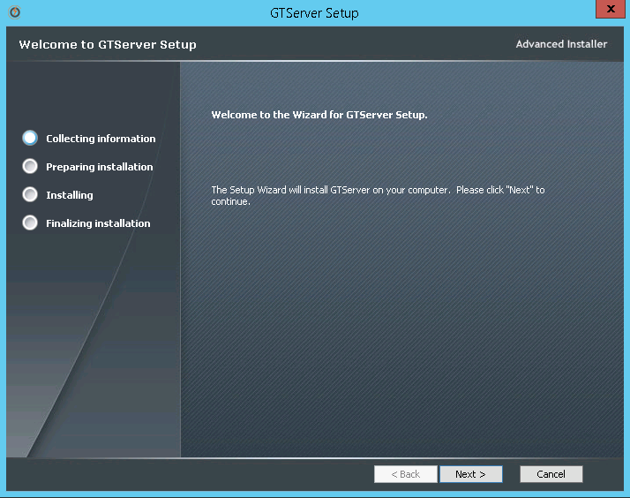

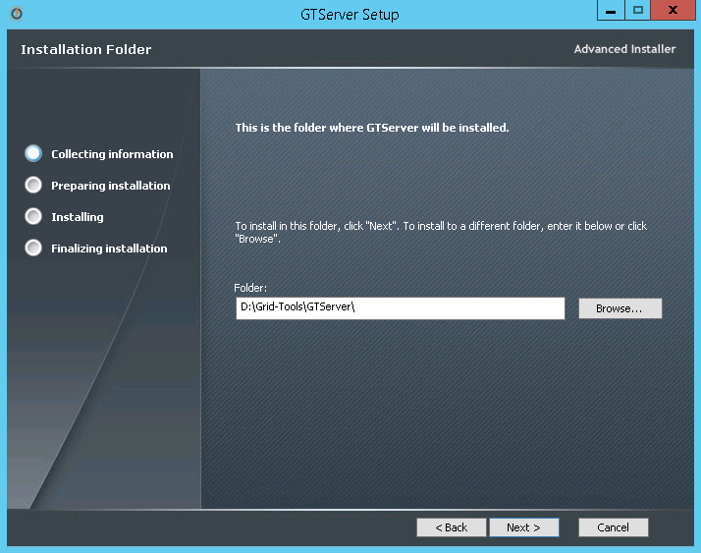

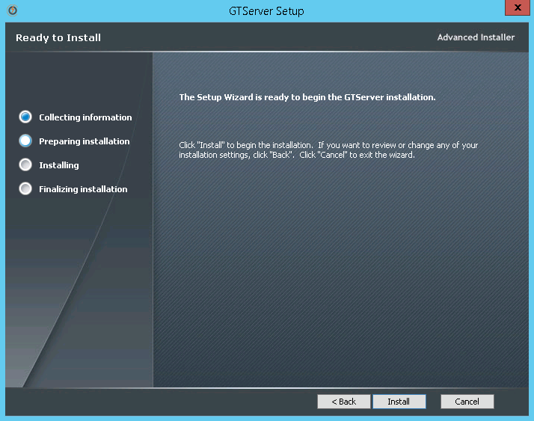

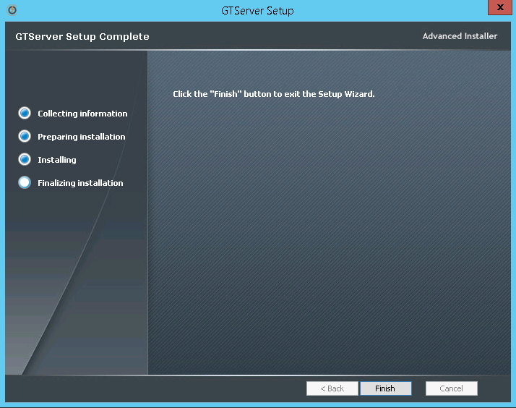

## **3.3 Renaming rep.xml file and syncing the repository database**

After the CA Test Data Manager upgrade completes, upgrade the repository by renaming the rep.xml file, performing the upgrade, and renaming the file again.

**Note:** The rep.xml lets you store repository credentials so you do not have to connect every time. If you do not use a rep.xml file, you can skip the steps related to the file.

1. Launch Datamaker using the Desktop icon or through the file system (TDM_HOME\Grid-Tools\GTDatamaker\gtdatamaker.exe).

The following message appears:

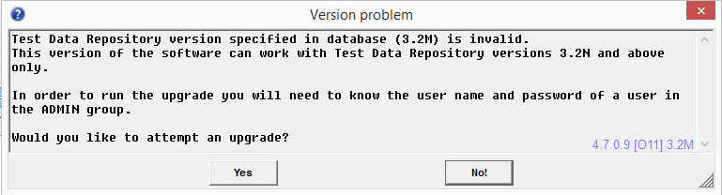

This message means that you must upgrade the repository before proceeding.

1. Navigate to the TDM_HOME\Grid-Tools\GTDatamaker directory, and rename the rep.xml file to rep-old.xml.
2. From the Windows Explorer dialog, type %appdata% into the file path and select the Grid-Tools folder in the results. Rename the rep.xml to rep-old.xml in this folder. If the rep.xml file does not exist at this location, skip to step 4.
3. Launch Datamaker again.  
   The Test Data Repository log in for CA Test Data Manager dialog opens. It includes the repository profile that you selected in the last installation.
4. Click the green database connection button.

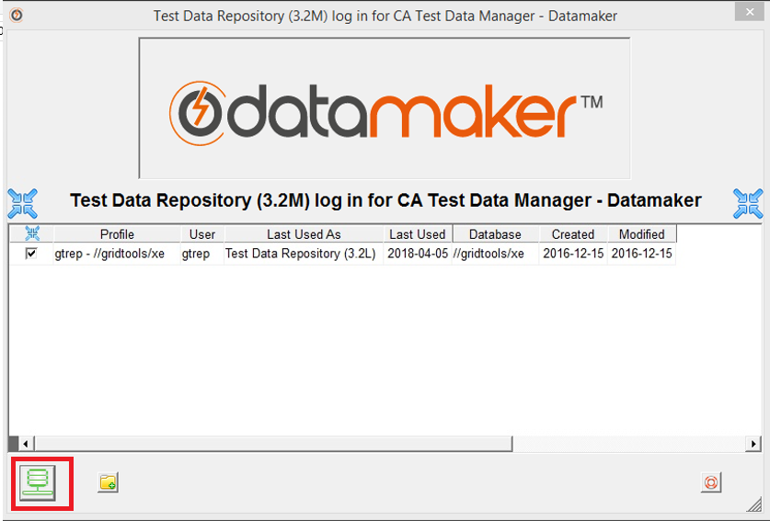  
The following message appears:



Note that if you do not see this message, it is most likely that the user that installed the product is not performing the upgrade. If this is the case, you will need to create a new repository profile and provide the appropriate connection details. Check the entry for the new profile and click the green database connection button. You should then see the above message.

1. Click Yes.

The login page opens.

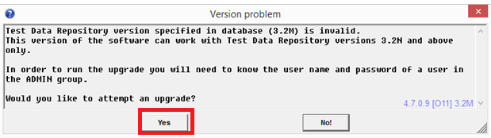

1. Log in with administrator credentials.

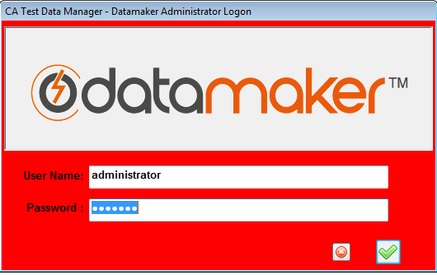  
The CA Test Data Manager - Datamaker Repository Schema - Updates Required message opens.

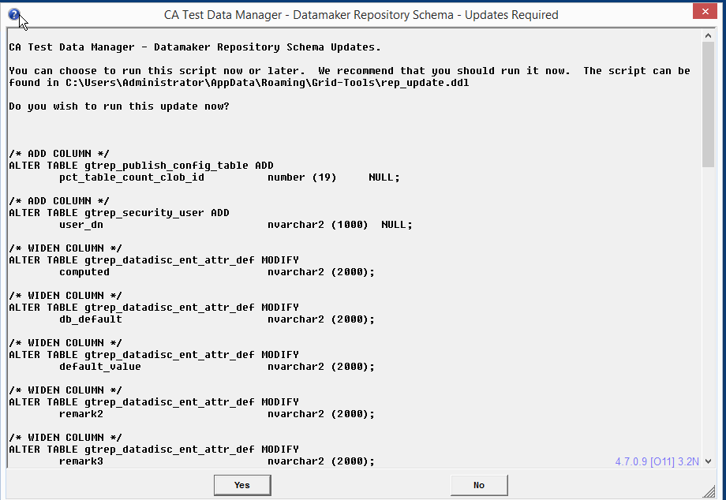

1. Click Yes.

The main Datamaker window opens.

1. Select Settings, Enter Activation Key.
2. Enter the activation key that you received from you license request, and click the Save button.  
   A confirmation opens. Click OK, and you should see a full listing of all connection profiles.
3. Close Datamaker.
4. Rename the rep-old.xml files to rep.xml in the TDM_HOME\Grid-Tools\GTDatamaker and %appdata%\Grid-Tools directories.
5. Launch Datamaker again.

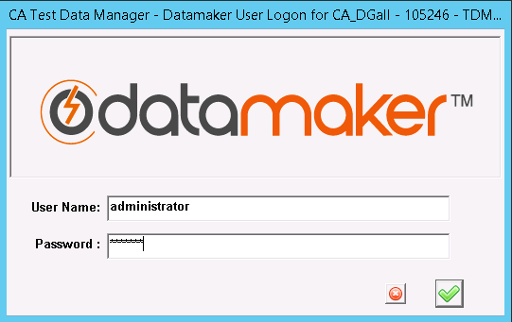  
You should be able to connect successfully to any connection profile.

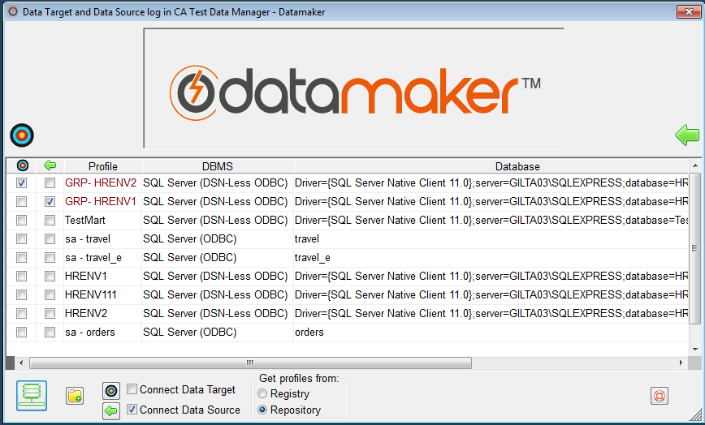

1. Repeat the process described in Perform Repository Maintenance to verify that no further repository maintenance is required:

<https://docops.ca.com/ca-test-data-manager/4-7/en/installing/install-ca-test-data-manager/perform-repository-maintenance>   
The upgrade is complete.

## **3.4 Maintenance mode in Datamaker**

After the successful Datamaker upgrade, You can run the Maintenance Mode on the Datamaker by running **CTRL + ALT + M**

Enter the Administrator credentials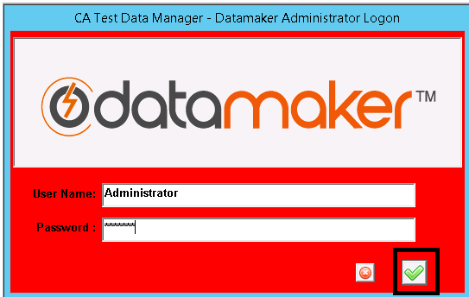

Choose “**Check Repository Tables**” and **Process**

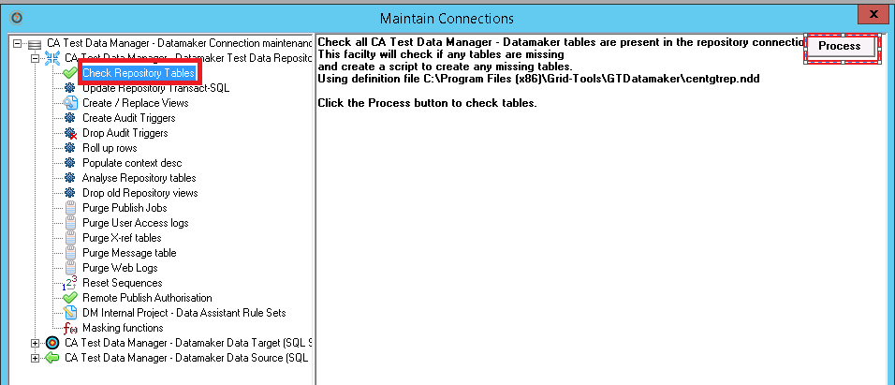

Expected Result: you will get **Repository Schema OK – No Updates required**

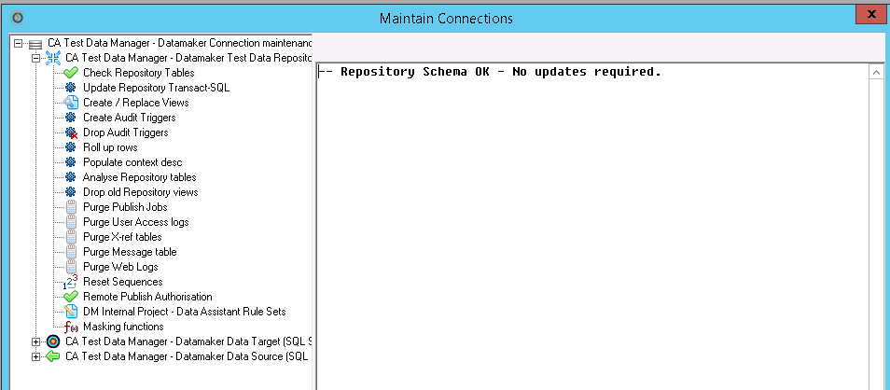

You might get below result – Inaccuracies found- Updates required, Run the Execute Script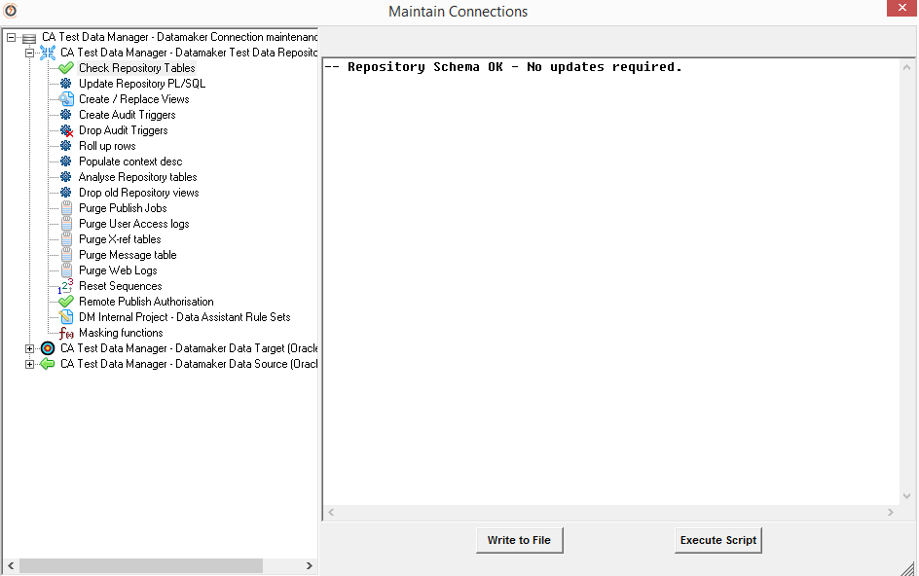

Execute Script, In 4.6 you might get the above screen , you can proceed to next step.

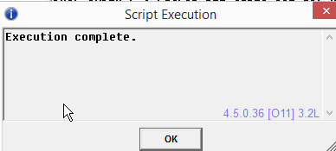

Select **Update Repository Transact-SQL** and select **Yes** to update all the repository Transact-SQL 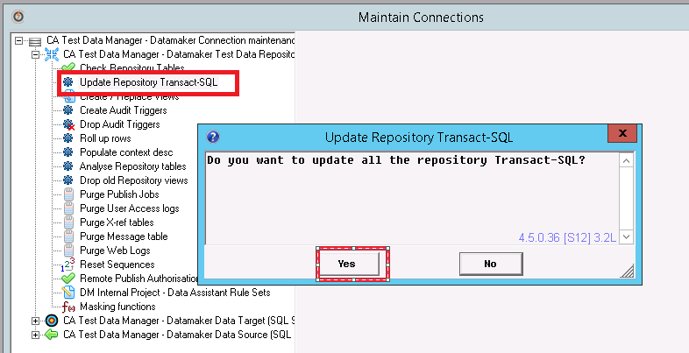

Select **OK**

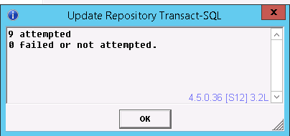

## **3.5 Upgrade steps to TDM Portal 4.x**

**Follow these steps:**

1. Verify that the CA Test Data Manager and the Repository are upgraded to the compatible version. For more information, see [Upgrade Product Components](https://docops.ca.com/ca-test-data-manager/4-7/en/installing/upgrade-product-components).
2. While the upgrade process will shut down the services, it is a good practice to shut down the following services prior to upgrade:
   1. CA Test Data Manager Portal 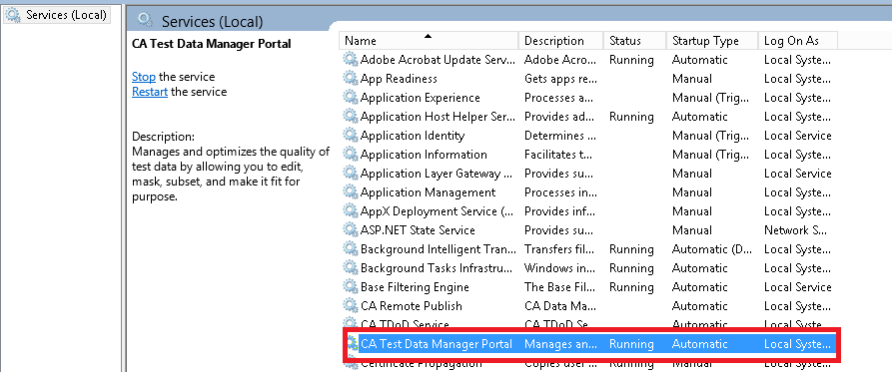

Right Click and Shut down 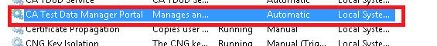

* 1. OrientDB

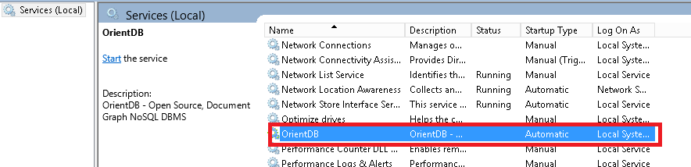

1. Extract the **CA Test Data Manager Full Package 4.X to find the setup_CA Test Data Manager Portal<version>.exe**

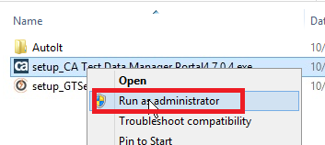

1. Right-click the setup_CA Test Data Manager Portal<version>.exe file and Run as administrator.

Ensure that you are installing the same version of TDM Portal as that of CA TDM.

1. A welcome dialog opens. Click **Next**.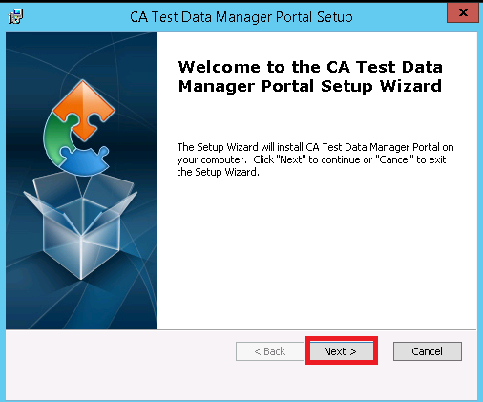
2. The **End User License Agreement** dialog opens. Accept the license agreement and click **Next**.

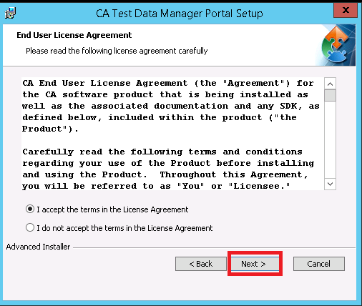

1. Review the upgrade information that is displayed on the dialog. Click **Next**.

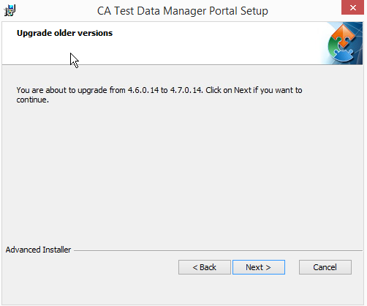

1. Review the message Ready to Upgrade and Click **Upgrade**.

Note: TDM Portal Upgrade once started cannot be rolled back.

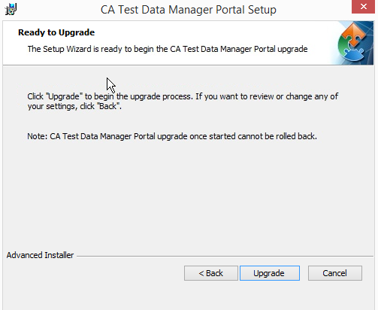

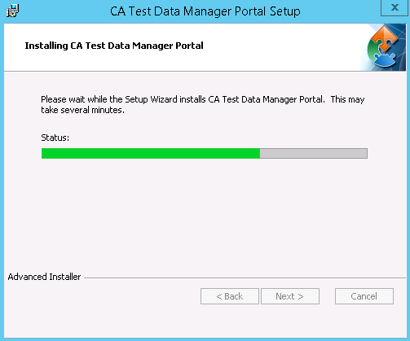

1. Click **Finish** when the upgrade completes.

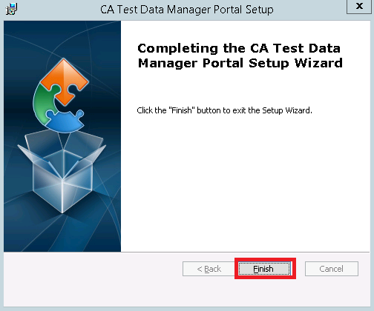

1. Open the Windows **Services** dialog (Start, services) and verify that the CA Test Data Manager Portal and OrientDB services are available and are running.

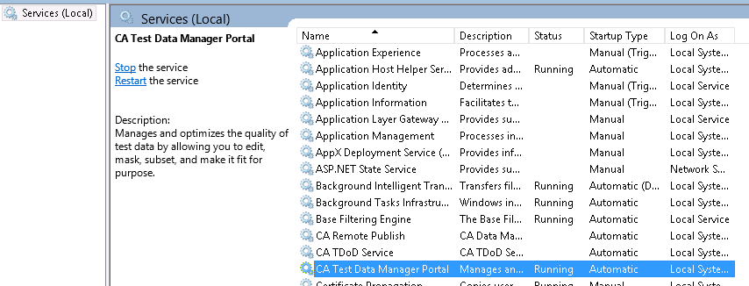

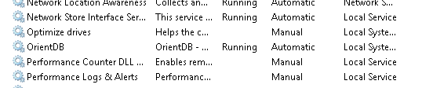

1. Upon completion, the services previously stopped should now be started. You can now review the startup.log located in the ..\Program Data\CA\CA Test Data Manager Portal\logs folder

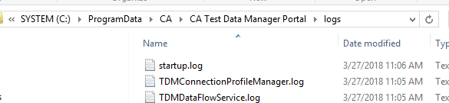

1. The Portal service is completely started when the last section TDM Main completes and you see the line “INFO: Server startup….”.

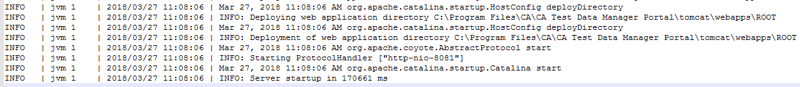

1. Upon logging into the Portal page, in the lower left corner should display the following to identify the upgrade:

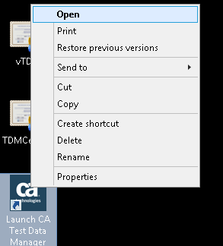

1. You can click on About button to get the Version Details

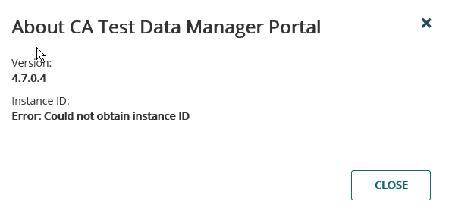

1. When you open TDM Portal first time, Customer Experience Improvement Screen pops out, Read It Carefully and Select Send Diagnostic and Usage Data and Save to enable Telemetry services to be enabled.

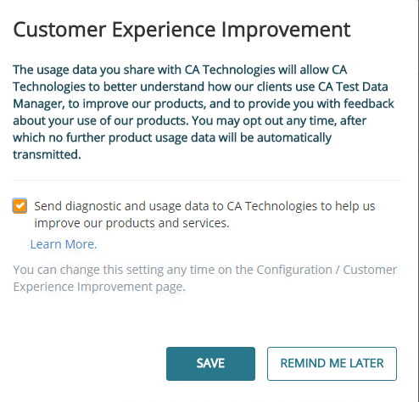

1. Clear the browsing cache

Screenshots for Internet Explorer shown below

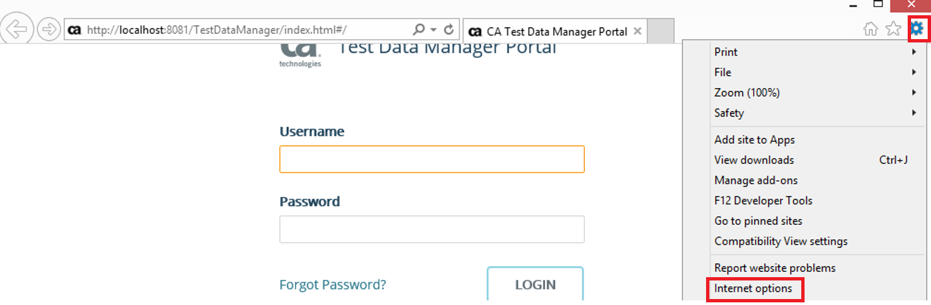

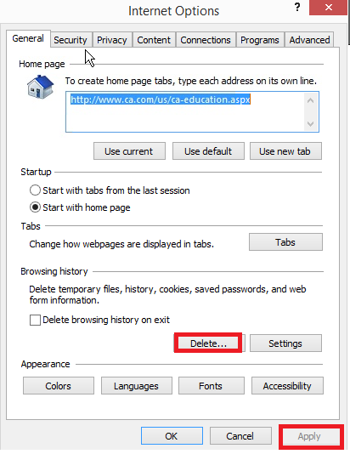

1. Close the browser and open it again.
2. You have successfully upgraded the CA TDM Portal instance.